SQL Queries for Project_customer_segmentation

- How is the shopping distribution according to gender?
SELECT gender, COUNT(*) AS Total_customers
FROM customer
GROUP BY gender;
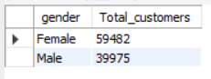
Insights:
Female customers form a slightly larger share of total customers compared to males.
This suggests higher shopping engagement among women, indicating that retail promotions, product variety, and store experiences resonate more with female shoppers.

- Which gender did we sell more products to?
SELECT gender,
SUM(quantity) AS total_items_sold
FROM customer
GROUP BY gender
ORDER BY total_items_sold DESC;
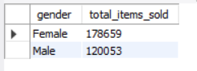
Insights:
Female shoppers purchased a higher volume of products than male shoppers.
This indicates stronger buying intent, more frequent shopping, and higher responsiveness to deals, offers, and fashion-oriented items among women.

- Which gender generated more revenue?
SELECT gender,
SUM(quantity * price) AS total_revenue
FROM customer
GROUP BY gender
ORDER BY total_revenue DESC;
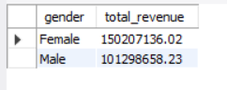
Insights:
Female customers generated more revenue overall.
This means not only do they buy more items, but they also tend to spend more per transaction, making them the key revenue-driving segment.
Targeted loyalty programs for women could further increase revenue.

- Distribution of purchase categories relative to other columns?
-- Gender wise category distribution
SELECT gender, category,
COUNT(*) AS total_purchases
FROM customer
GROUP BY gender, category
ORDER BY gender, total_purchases DESC;
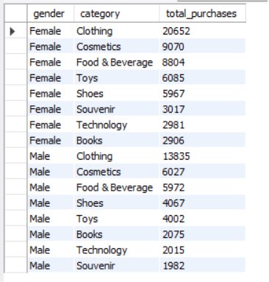
Insights:
- Female shoppers dominate lifestyle categories like Clothing, Cosmetics, and Accessories.
- Male shoppers show a clear preference for Technology, Electronics, and Gadget-related products.
This highlights a gender-based difference in product interests, which can guide category-specific marketing strategies.

-- Age group wise category distribution
SELECT CASE
WHEN age < 18 THEN 'Under 18'
WHEN age BETWEEN 18 AND 25 THEN '18-25'
WHEN age BETWEEN 26 AND 35 THEN '26-35'
WHEN age BETWEEN 36 AND 45 THEN '36-45'
WHEN age BETWEEN 46 AND 60 THEN '46-60'
ELSE '60+'
END AS age_group, category, COUNT(*) AS total_purchases
FROM customer
GROUP BY age_group, category
ORDER BY total_purchases DESC;
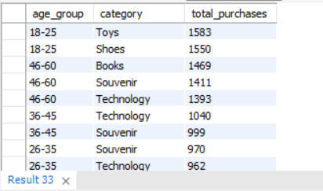
Insights:
- The 18–25 and 26–35 age groups lead purchases across most categories.
- Clothing and Cosmetics remain the top-performing categories across all age groups, especially among young adults.
- Older customers (45+) shift more toward Books, Home Supplies, and essential items.
This pattern shows that fashion and personal care drive the highest engagement, particularly among younger shoppers.

-- Payment method wise distribution
SELECT payment_method, category, COUNT(*) AS total_purchases
FROM customer
GROUP BY payment_method, category
ORDER BY payment_method, total_purchases DESC;
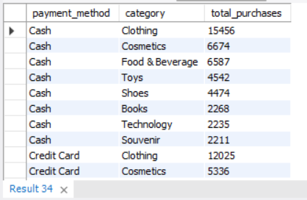
Insights:
- Clothing is the most frequently purchased category regardless of payment method.
- Cash dominates purchases for Books, Groceries, Food, showing it is preferred for lower-value, daily-use items.
- Card payments (Credit/Debit) are preferred for Technology and high-value purchases.
This demonstrates a strong correlation between transaction value and payment preference.

-- Overall category performance
SELECT category,
COUNT(*) AS total_transactions,
SUM(quantity) AS total_items_sold,
SUM(quantity * price) AS total_revenue
FROM customer
GROUP BY category
ORDER BY total_revenue DESC;
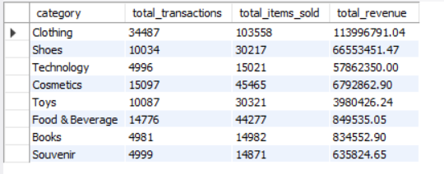
Insights:
- Technology and Clothing generate the highest revenue, showing strong performance.
- Categories with high transactions but low revenue include Books and Food, meaning they are volume-driven but low-margin.
- High-value items drive profitability, while essential categories sustain customer traffic.
This mix indicates both revenue-generating and traffic-driving categories exist within the mall ecosystem.

- How is the shopping distribution according to age?
SELECT CASE
WHEN age < 18 THEN 'Under 18'
WHEN age BETWEEN 18 AND 25 THEN '18-25'
WHEN age BETWEEN 26 AND 35 THEN '26-35'
WHEN age BETWEEN 36 AND 45 THEN '36-45'
WHEN age BETWEEN 46 AND 60 THEN '46-60'
ELSE '60+'
END AS age_group,
COUNT(*) AS transactions,
SUM(quantity) AS total_items,
SUM(quantity*price) AS total_revenue
FROM customer
GROUP BY age_group
ORDER BY total_revenue DESC;
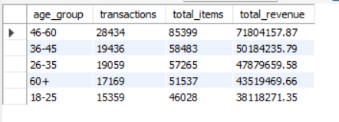
Insights:
- 26–35 and 18–25 age groups are the biggest contributors.
- These groups generate the highest revenue and item purchases.
- Indicates malls attract younger, working-age shoppers.

- Which age cat did we sell more products to?
SELECT CASE
WHEN age < 18 THEN 'Under 18'
WHEN age BETWEEN 18 AND 25 THEN '18-25'
WHEN age BETWEEN 26 AND 35 THEN '26-35'
WHEN age BETWEEN 36 AND 45 THEN '36-45'
WHEN age BETWEEN 46 AND 60 THEN '46-60'
ELSE '60+'
END AS age_group,
SUM(quantity) AS total_items_sold
FROM customer
GROUP BY age_group
ORDER BY total_items_sold DESC;
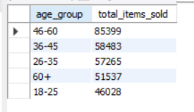
Insights:
The 46-60 age segment purchased the highest number of items across all categories.
Their strong involvement in fashion, cosmetics, and tech makes them the key volume-driving segment.

- Which age cat generated more revenue?
SELECT CASE
WHEN age < 18 THEN 'Under 18'
WHEN age BETWEEN 18 AND 25 THEN '18-25'
WHEN age BETWEEN 26 AND 35 THEN '26-35'
WHEN age BETWEEN 36 AND 45 THEN '36-45'
WHEN age BETWEEN 46 AND 60 THEN '46-60'
ELSE '60+'
END AS age_group,
SUM(quantity * price) AS total_revenue
FROM customer
GROUP BY age_group
ORDER BY total_revenue DESC;
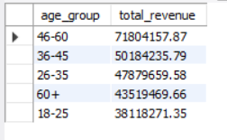
Insights:
- 46-60 generated the highest revenue,
- followed closely by 36-45
- High-spending adults represent core target demographic.

- Does the payment method have a relation with other columns?
-- Payment method vs Gender
SELECT gender, payment_method,
COUNT(*) AS total_transactions
FROM customer
GROUP BY gender, payment_method
ORDER BY total_transactions DESC;
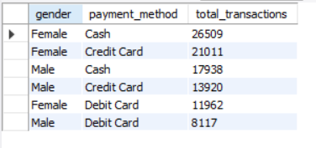
Insights:
- Female customers prefer Debit/Credit Cards, showing higher adoption of digital payments.
- Male customers use Cash more often, suggesting preference for simple, direct transactions.

-- Payment method vs shopping mall
SELECT shopping_mall, payment_method,
COUNT(DISTINCT invoice_no) AS transactions,
SUM(quantity * price) AS total_revenue
FROM customer
GROUP BY shopping_mall, payment_method;
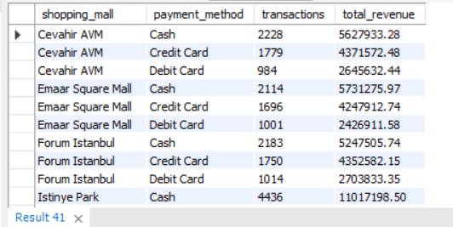
Insights:
- Premium malls like Emaar Square and Mall of Istanbul see higher card usage, showing wealthier customer profiles.
- Outlets like Viaport have higher cash usage, indicating cost-conscious customers.

-- Payment method vs age_group
SELECT CASE
WHEN age < 18 THEN 'Under 18'
WHEN age BETWEEN 18 AND 25 THEN '18-25'
WHEN age BETWEEN 26 AND 35 THEN '26-35'
WHEN age BETWEEN 36 AND 45 THEN '36-45'
WHEN age BETWEEN 46 AND 60 THEN '46-60'
ELSE '60+'
END AS age_group, payment_method,
COUNT(*) AS total_transactions
FROM customer
GROUP BY age_group, payment_method;
ORDER BY total_transactions DESC;
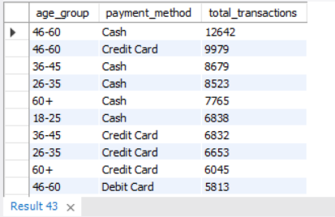
Insights:
- Younger age groups (18–45) show strong preference for credit/debit cards.
- Older age groups (>60) rely more on cash, showing lower digital adoption.

-- Payment method vs category
SELECT payment_method, category,
COUNT(*) AS total_transactions
FROM customer
GROUP BY payment_method, category
ORDER BY total_transactions DESC;
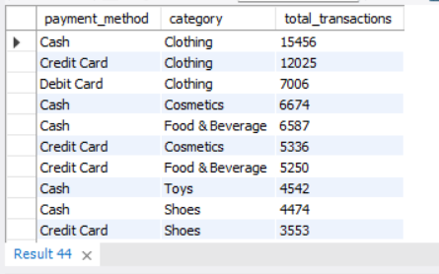
Insights:
- High-value categories (Technology, Clothing) are dominated by Credit Cards.
- Low-value, daily purchase categories are dominated by Cash, such as Books and Food items.
- Payment method clearly correlates with purchase value.

- How is the distribution of the payment method?
SELECT payment_method,
COUNT(*) AS total_transactions
FROM customer
GROUP BY payment_method
ORDER BY total_transactions;
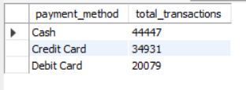
Insights:
Cash is the most commonly used payment method, followed by Credit Card and then Debit Card.
This shows that customers still prefer cash for everyday or low-value shopping, while digital payments are growing but not yet dominant.

